1. **COLD CUP 16 OZ**

|  |  |
| --- | --- |
| Packaging | 1000pcs/box |
| Gramatur Kertas | 250 Gsm |
| Diameter atas | 8,2 cm |
| Diameter bawah | 6 cm |
| Tinggi | 12,7 cm |
| Volume Capacity | 480 ml |

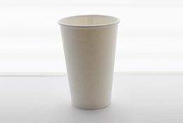

1. **HOT CUP 12 OZ**

|  |  |
| --- | --- |
| Packaging | 1000pcs/box |
| Gramatur Kertas | 250 Gsm |
| Diameter atas | 8,2 cm |
| Diameter bawah | 6 cm |
| Tinggi | 10.2 cm |
| Volume Capacity | 360 ml |

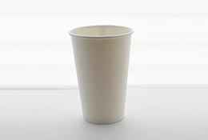

1. **Cold Cup 12 oz**

|  |  |
| --- | --- |
| Packaging | 1000pcs/box |
| Gramatur Kertas | 250 Gsm |
| Diameter atas | 8,2 cm |
| Diameter bawah | 6 cm |
| Tinggi | 10,2 cm |
| Volume Capacity | 360 ml |



1. **Hot Cuo 8 oz**

|  |  |
| --- | --- |
| ackaging | 1000pcs/box |
| Gramatur Kertas | 250 Gsm |
| Diameter atas | 7,5cm |
| Diameter bawah | 5,5cm |
| Tinggi | 9,5cm |
| Volume Capacity | 240ml |

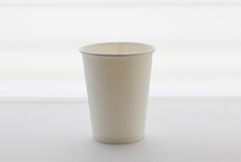

1. **Hot Cup 16 Oz**

|  |  |
| --- | --- |
| Packaging | 1000pcs/box |
| Gramatur Kertas | 250 Gsm |
| Diameter atas | 8,2 cm |
| Diameter bawah | 6 cm |
| Tinggi | 12,7 cm |
| Volume Capacity | 480 ml |



1. **Cold Cup 22 Oz**

|  |  |
| --- | --- |
| Packaging | 1000pcs/box |
| Gramatur Kertas | 250 Gsm |
| Diameter atas | 8,5 cm |
| Diameter bawah | 5,5 cm |
| Tinggi | 14,7 cm |
| Volume Capacity | 650 ml |

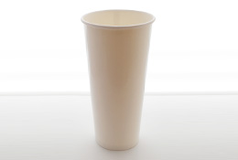

1. **Clear Lid Flat ( Cold 12 oz & 16 oz) 6. Clear Lid Dome (Cold 12 oz & 16 oz)**

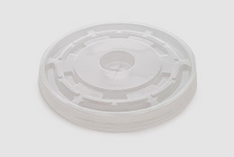 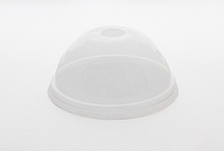

1. **Blister Lid (Hot Cup 8 oz & 12 oz) 8. Stirer ( Untuk Hot Cup )**

